
T
cobas® 8000 modular analyzer series
Short Guide Version 2.0
Table of Contents

Table of Contents | 1
System Overview - Workflow Guide | 2
Starting Inspection | 2
How to select calibrations and controls | 3
Requesting calibrations and controls using Overview screen | 3
Requesting calibrations in Calibration Status screen | 4
QC after calibration | 4
Requesting controls in QC Status screen | 4
Start Routine | 5
End of Routine | 5
How to install a new application | 6
Loading new application parameters | 6
Test Parameter Setting | 7
Test Assignment | 7
Test Key Assignment | 8
Configuration in Utility | 8
Set up Calibrators | 9
Set up Calibrators manually (for chemistry only) | 10
Set up Roche Controls | 10
Edit target values and ranges for Roche controls | 11
Edit target values and ranges for non Roche controls | 11
Set up non Roche Controls | 12
Rack Assignment for non barcoded calibrators and controls | 13

System Overview - Workflow Guide

Starting Inspection
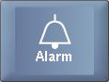

Check system alarms.
Select beginning of the day maintenance. Select Clear or Backup and Clear.
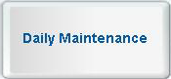

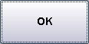

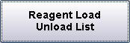



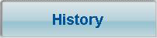

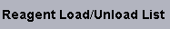

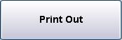

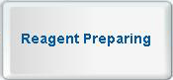
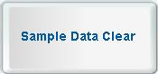

Print load list.
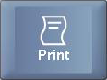

Activate the Preventive Action check box, if not selected.

Load reagents and auxillary reagents onto the analyzer according to reagent load list. Remove all empty packs from the system.

 Perform Prime for ISE. Select all.  After the Reagent Prime for ISE, recalibrate the ISE unit before you resume routine operation.

How to select calibrations and controls

Requesting calibrations and controls using Overview screen

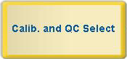 Calibration area  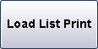

QC area 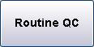 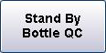

Print load list.

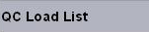

Load calibrator and QC racks on the analyzer according to calibrator and QC load list.

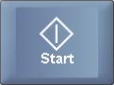


Requesting calibrations in Calibration Status screen

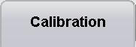
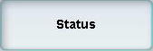

Select test. Select calibration method e.g. .  Calibration request is active when bar is blue 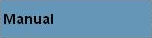.
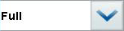

Print load list.

QC after calibration

- Insert the QC rack directly after the calibrator racks.

Requesting controls in QC Status screen

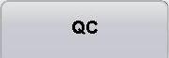

Select test

or select 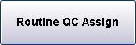 for all active Reagent Packs.

Select 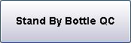 for Stand by QC. Select test 

Print load list.

Start Routine

Load racks with samples.

End of Routine

Deselect rack reception mode, if necessary.

Area Rack Reception Mode


Deselect  Rack Reception Mode.

Load green rack:
Pos. 1 MultiClean Pos. 2 SysClean Pos. 3 Activator

How to install a new application
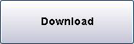

Loading new application parameters
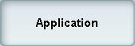

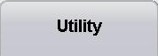

Select one of the available search conditions.  Activate the check box of parameter to be downloaded.
Select the unit, if necessary:  Check if the parameters are downloaded.

c 701 / c 502: For first installation parameters for dilution and cleaner reagent packs have to be downloaded.

Test Parameter Setting

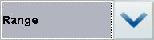

Test Assignment

 Select

Optional settings Define decimal places, select Automatic

Rerun, define Control Interval time,
AutoQC on board stability, Repeat Limit, Qualitative fields.


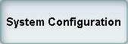

Select ISE module. Select Na, K, Cl or Na, K.

Select c 701 module. Select checkbox 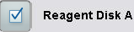, 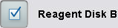 Select c 502 module. Select checkbox
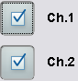

Select c 602 module. Select checkbox

Test Key Assignment

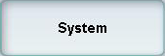

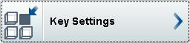

Select 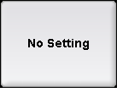
Select a test. 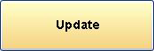

Configuration in Utility



Select option for Routine/Stat, Calibrator and Control.
Select checkmark and Hours.
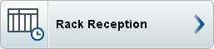

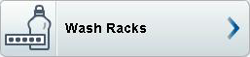

Define cycles for wash rack: photometric: 5, ISE: 15.



Select Expired Reagent Flag.

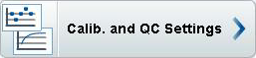

Select Auto Masking. Select Reagent Information Printout.



Select Print Dilution Ratio.

Set up Calibrators

Load reagent packs on the module.
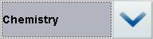




Select one of the available search conditions.

Activate the check box of the parameter to be downloaded.

Set up Calibrators manually (for chemistry only)

Select an empty line.

 Type in calibrator name, code, lot no., and expiration date. 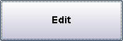 Type in the concentration values.

Set up Roche Controls

Load reagent packs on the module.

Select one of the available search conditions. Activate the check box of the parameter to be downloaded.

Edit target values and ranges for Roche controls

Log on to data manager. Select Control Material.
Select Highlight the control material you want to edit.

Select Highlight the test you want to edit. Select Select .
Type in the value.

Edit target values and ranges for non Roche controls

Log on to data manager. Select Control Material.
Select Highlight the control material you want to edit.

Select Highlight the test you want to edit. Select Type in the value.

Set up non Roche Controls

Log on to data manager. Select Control Material.
Select and right-click in the work area.

Select on the shortcut menu.

Complete the fields according to the information from the control material manufacturer.
- Control name
- Control Code (enter a number between 25000 - 32000)
- Sample type
- Lot No.
- Expiry date
- Instrument
- Test

to save the test without closing the window, or to save the test and close the window.
Rack Assignment for non barcoded calibrators and controls

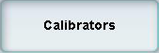

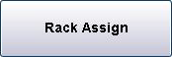

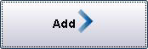

To remove the assignment 

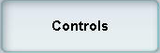

To remove the assignment

Do not mix barcoded and non-barcoded calibrators/ controls on the same rack.

